Come Home To

Hunter's Ridge



WWW.HUNTERSRIDGE.WEEBLY.COM

**1079 Springhouse Drive**

**Columbia, South Carolina 29210**

**Ph: 803-798-0610**

**Fx: 803-731-5260**

Hunter’s Ridge Apartments

**Because we are committed to excellence, affordability, convenience, and service.**

**Hunter's Ridge offers you peacefulness nestled in a beautifully landscaped area. We are only minutes from major shopping malls, entertainment, fine restaurants, and easy access to I-20 and I-26 for convenient travel anywhere. Hunter's Ridge is designed for those who want the best and most enjoyable in apartment living.**

**Make Hunter's Ridge your new home!**

WWW.HUNTERSRIDGE.WEEBLY.COM

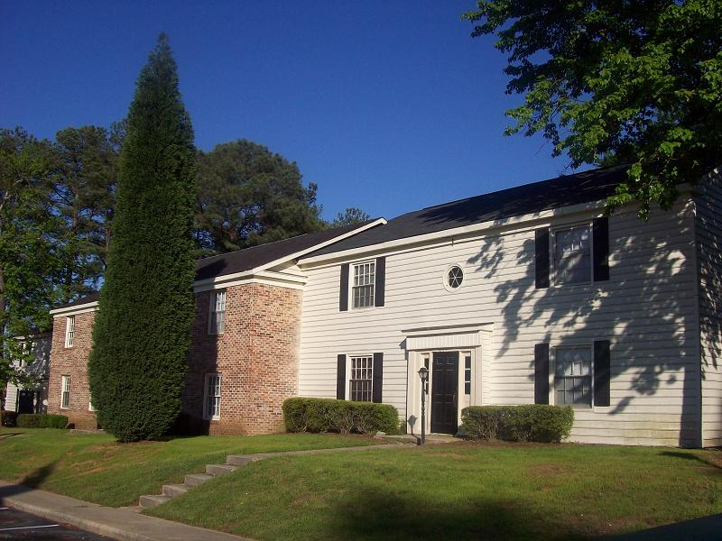

**Hunter’s Ridge Apartments**

**1079 Springhouse Drive**

**Columbia, South Carolina 29210**

**Ph: 803-798-0610**

**Fx: 803-731-5260**

**Directions**

**From I-26 exit St. Andrews Rd. (106B).Continue to Broad River Rd. & turn right at traffic light,**

**Come about 1 mile turn right onto Zimalcrest Rd. Entrance is on the right.**

**From I-20, exit Broad River Rd. north. Travel 1/2 mile and turn left onto Zimalcrest Rd.**

**Drive slowly, entrance on right.**

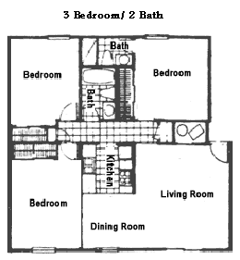

1176 Sq Ft.

$________ Per Month

985 Sq Ft.

$_________ Per Month

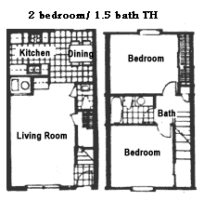

834 Sq Ft.

$__________ Per Month

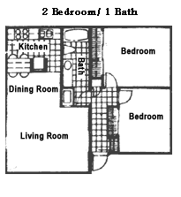

655 Sq Ft.

$___________ Per Month

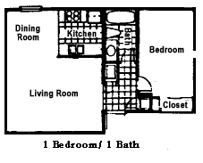

Hunter’s Ridge

Apartment Features

* Plush Carpeting
* Cable Connections
* Ceiling Fans
* Frost Free Refrigerator
* Dishwasher
* Private Patio or Balcony
* Mini Blinds
* Large Bedroom Closets
* Extra Storage
* Spacious Floorplans
* Washer & Dryer Connections*
* Cathedral Ceilings*
* Whirpool Tubs*
* In Selected Units

Community Amenities

* Community Clubhouse with fireplace
* Sparkling Swimming Pool with Sun Deck
* Children's Playarea
* On-Site 24 hour laundry facility
* Picnic Area
* Expertly Maintained Landscape
* 24 hour Emergency Maintenance
* Friendly & Courteous Staff
* On-Site Courtesy Officer
* Easy access to I-20/I-26
* Minutes away from Shopping

